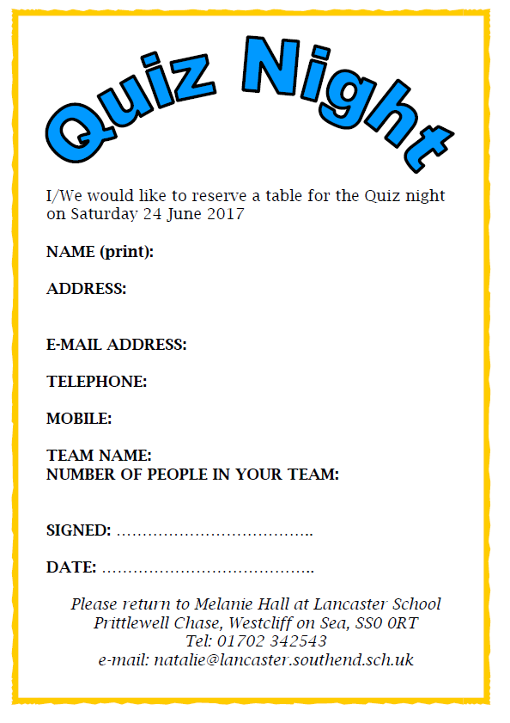
NAME (print):
ADDRESS:

E-MAIL ADDRESS:
TELEPHONE:
MOBILE:
TEAM NAME:
NUMBER OF PEOPLE IN YOUR TEAM:
SIGNED: ……………………………………
DATE: ……………………………………….
Please return to the office at Lancaster School Prittlewell Chase, Westcliff on Sea, SS0 0RT
Tel: 01702 342543
E-mail: office@lancaster.southend.sch.uk
I/We would like to reserve a table for the Quiz Night on Saturday 14th March 2020 at 7pm.


Fantastic auction and raffle prizes
Lancaster School Hall
Bring your own nibbles and drink, alcohol permitted!!!
Saturday 14th March 2020
7:00pm

If you would like to reserve a table please contact the school on 01702 342542
T
Teams of 8-10 people £5 per person
Lancaster School Presents a:

