Your class Team can be accessed by either PC, Laptop, Tablet or Mobile.

For PC or Laptop:

- Go to www.office.com.

- Login with student email address and password.
Student email address is the student’s initial and surname followed by @lancaster.southend.sch.uk
For example, Mickey Mouse would be mmouse@lancaster.southend.sch.uk
The password is Lancaster1 and will ask you to change.
New password needs to have
- At least 8 digits.
- A capital letter.
- A number.

- Login and then click on the Teams icon
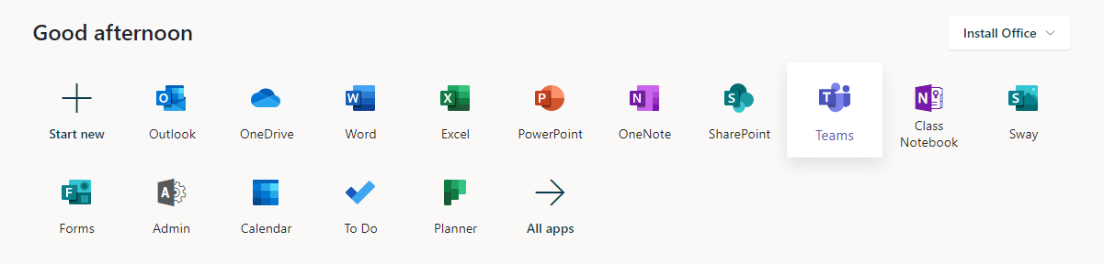

- Teams can be downloaded (Windows app) but your do not need to. Click ‘Use the web app’ instead.
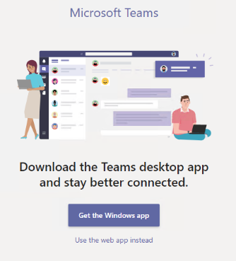

For Tablet or Mobile

- Download the free Microsoft Teams App from your app store.
- Login with student email address and password.
Student email address is the student’s initial and surname followed by @lancaster.southend.sch.uk
For example, Mickey Mouse would be mmouse@lancaster.southend.sch.uk
The password is Lancaster1 and will ask you to change.
New password needs to have
- At least 8 digits.
- A capital letter.
- A number.

Once you have access to Teams students will be able to use it to chat to friends, access their work and have scheduled video calls but it is not to be used as a way of messaging and ringing staff unless within the class team chat itself.

